1. Explain the purpose of the map() function and provide an example of its use.

The map function is used to impose one range of values onto another, and a common use for this function in Arduino is to map between 8-bit and 10-bit numbers when using analog/digital read/write.

1. Explain the purpose of the constrain() function and provide an example of its use.

The constrain function takes a value and puts it inside a defined range. If the number is larger or smaller than the range boundary, it will set the number equal to the range boundary. This can be used to ensure a sensor value stays between two limits.

1. What is a voltage divider? Draw the schematic of a simple voltage divider circuit.

A voltage divider uses resistance to output a specific voltage level to the node following it.

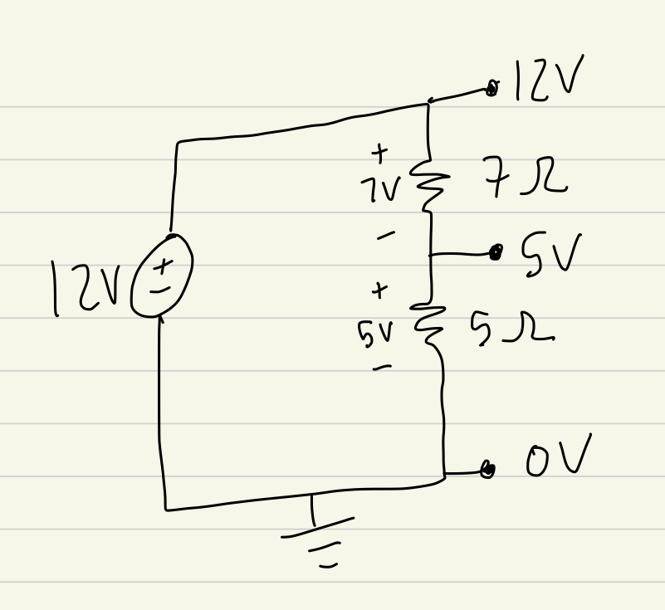

1. Provide an example of when to use a voltage divider.

A voltage divider is needed when the input voltage to the system is higher than the required voltage of the components.

1. What is an H-bridge and what is it used for? Draw a diagram of how the H-bridge is used to control the direction of a motor.

An H-bridge is used to reverse the direction of the motors.

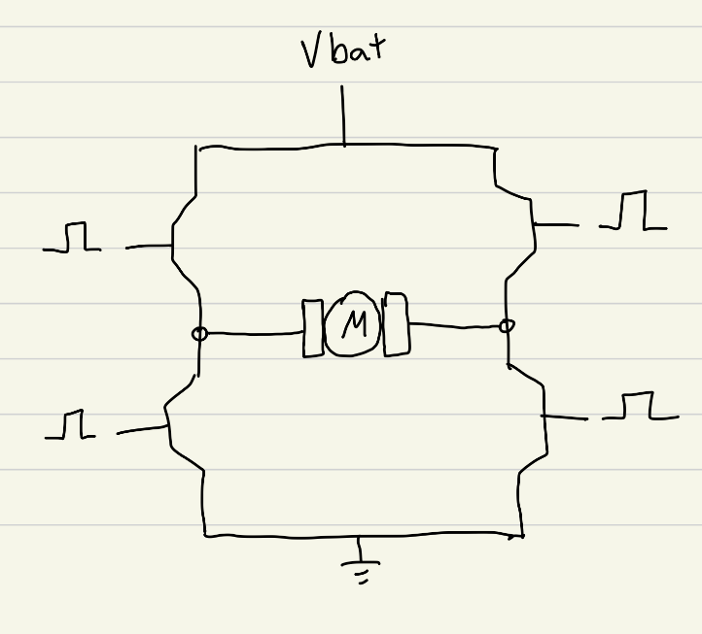

1. Read the datasheet for the L293D H-bridge (<http://www.ti.com/lit/ds/symlink/l293.pdf>) and pages 74 – 75 from the textbook

Explain what the each of the following pins are used for:

|  |  |  |  |
| --- | --- | --- | --- |
| i. | Heat Sink/Ground | (Pins 4, 5, 12, and 13) |  |
| ii. | VCC2 | (Pin 8) | **Power VCC for drivers** |
| iii. | VCC1 | (Pin 16) | **5V supply for internal logic** |
| iv. | 1Y and 2Y | (Pins 3 and 6) | **Driver Outputs** |
| v. | 1A and 2A | (Pins 2 and 7) | **Driver Inputs** |
| vi. | 1,2 EN | (Pin 1) | **Enable driver channels 1&2** |
| vii. | 3Y and 4Y | (Pins 11 and 14) | **Driver outputs** |
| viii. | 3A and 4A | (Pins 10 and 15) | **Driver inputs** |
| ix. | 3,4 EN | (Pin 9) | **Enable driver channels 3&4** |

1. What precautions should you take to prevent the H-bridge from accidentally short circuiting?

Pay close attention to the orientation of the H-bridge and the identifying circle at the top as well as turning off the power before manipulating the system.

1. Explain the differences between the bipolar and unipolar stepper motors in terms of torque and speed briefly?

Bipolar stepper motors have more torque, speed, and better efficiency, but are more complicated. Unipolar stepper motors are slower and less efficient with less torque but are easier to use.

1. Based on the reading of the 28byj -48 unipolar stepper motor datasheet you have in your kit, how many steps per full rotation (360°) in both half-step and full-step modes? (hint: this motor has 64:1 gear reduction ) ?

The step angle is 5.625 degrees so there are 64 steps per full rotation in full-step mode and 128 steps per full rotation in half-step mode.